Print Your Name: ___________________________

CLEA - Photoelectric Photometry of the Pleiades

Procedure
Absolute |  | Spectral
Magnitude (M) | B-V | Type
-5.8 | -0.35 | O5
-4.1 | -0.31 | BO
-1.1 | -0.16 | B5
-0.7 | 0 | AO
2 | 0.13 | A5
2.6 | 0.27 | F0
3.4 | 0.42 | F5
4.4 | 0.58 | GO
5.1 | 0.7 | G5
5.9 | 0.89 | KO
7.3 | 1.18 | K5
9 | 1.45 | MO
11.8 | 1.63 | M5
16 | 1.8 | M8

- Plot the data from the table on the “Absolute Magnitude versus Color Index” graph.

- Install “PhotoLab.EXE” using the link on the course home page.

- Log in and enter student information.

- Click “Run” and familiarize yourself with the controls. Open the observatory.

- Take “sky” counts. Take “star” readings, and record your results.

Your Star Number: _______

RA: __________________ DEC: __________________

U: _______ B: _________ V: _______ B-V: __________

6. Use your graph from part 1 above and the value of B-V for your star to estimate the absolute magnitude of your star (M). Use the visual magnitude (V) for your apparent magnitude (m). Find the distance to your star in parsecs using the equation below.

M = __________ m = __________ d = 10 x 10^{(m-M)/5} = ____________parsecs

7. Complete the table attached with the help of your classmates.

8. Plot the V column versus the B-V column for the “Apparent Magnitude versus Color Index” graph.

9. Overlay your two graphs to find an average value of (m-M). Calculate the distance to the cluster in parsecs. Then convert your answer to light years. Note that 1 parsec = 3.26 light years.

m - M = _________________(from graph overlay)

Distance to the Pleiades: _________________parsecs

Distance to the Pleiades: _________________light years

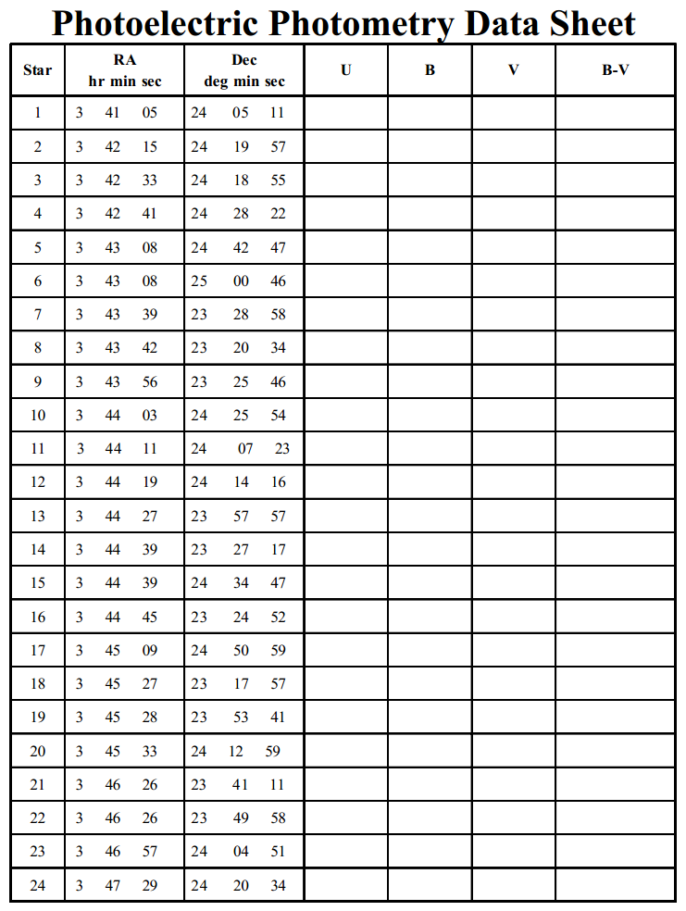

Main Sequence Stars

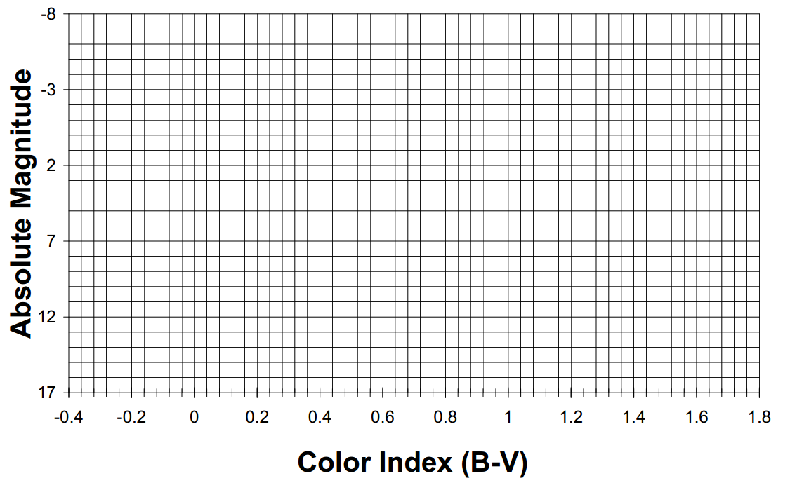

Pleiades

