Print Your Name:________________________________

Star Gauging (Star Counting)

In 1785 William Hershel, the discoverer of the planet Uranus, attempted to count the number of stars in various regions of the sky in the first attempt at mapping the star distribution in the Milky Way galaxy. He found that the galaxy was disk-shaped.

We can emulate Hershel’s work with a very primitive “telescope.” Our telescope will be the tube of a roll of paper towel. It’s not practical to count each star, so we take a statistical approach. We will point the telescope at selected patches of sky, count the numbers of stars that we see, and multiply by the total number of similar sized patches covering the entire sky.

To begin we must calculate the angular field of view of the paper towel roll.

1. Measure the radius (r) of the tube in cm. _____________
r
2. Measure the length (L) of the tube in cm. _____________
L
3. Divide r/L ________________

- Take the inverse tangent of the result in 3. I will use the calculator in Windows to demonstrate how this calculation is done. The calculator is found under Programs/Accessories in Windows. The default display in the program is the standard calculator, but we want the scientific calculator. Click on the View tab on the menu bar and select scientific. The calculator now looks like…

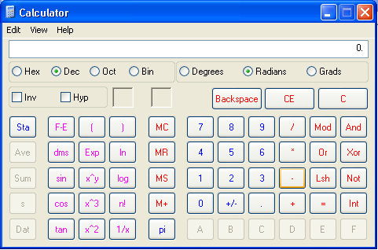

Notice that the radio buttons just under the entry region show us that the calculator has been set for Dec (decimal) output and Radians display. Enter the number from part 3 above, press the “Inv” square at upper left and then the “tan” function at lower left. Your result will be in radians and should be close to 0.08 rad. ______________

- Calculate the area of the field of view of the tube by squaring the result in part 4 and multiplying by pi (3.1415926). Notice that pi is stored for you in the calculator (lower center). Area = ______________. The result is in a solid angle measure called steradians.

- The area of the entire sky in steradians is 4π or about 12.566. To find out how many paper towel tube areas will cover the entire sky, simply divide 4π by the result of part 5. ______________

Observations:

We will observe several patches of sky at fixed altitude (angle from the horizon). Face toward the cardinal compass points (North, South, East, and West). The table below should be filled in with star counts from altitudes on 30°, 60°, and directly overhead.

Sky Region | Direction | Altitude | Star Count
1 | North | 30°
2 | South | 30°
3 | East | 30°
4 | West | 30°
5 | North | 60°
6 | South | 60°
7 | East | 60°
8 | West | 60°
9 | Zenith | 90°
 |  | Total Stars
 |  | Average
Zenith

Polaris

S
N

E

The total stars entry can be obtained by multiplying the average star count by the number in part 6 above.

Number of Stars = _____________ × _________________= ___________________stars

Your result indicates how many stars you can see with your naked eye. You can see many more stars with the aid of a telescope of course!

