Print Your Name: ___________________________

Practice Exam III – Review
You will not need to turn this handout in for a grade. Use the book Stars and Planets and Practical Astronomy with your Calculator or Spreadsheet to work these problems. Review your homework assignments and night lab handouts. (Homework 7 & 8)

1. What is the angle between Betelgeuse (5^{h} 55^{m} 10.3053^{s}, +07º 24' 25.426") and Rigel (05^{h} 14^{m} 32.2723^{s}, -08º 12' 05.906")? These coordinates are from SIMBAD. The acronym SIMBAD stands for Set of Identifications, Measurements, and Bibliography for Astronomical Data. Show your work. Express all of the parameters below in decimal degrees with the following format (123.456789°).

α₁ = ________________
δ₁ = ________________
α₂ = ________________
δ₂ = ________________
____________________

2. In 1979 Dr. Markworth took the AST305 class to Canada to watch a solar eclipse. Assume that their latitude was 65°. What is the azimuth of the sun at sunset and sunrise on the day of the summer solstice and winter solstice at that location? Use 3 significant figures. Show your work. Repeat the exercise for a latitude of 75°. Note that you may get strange results that you must explain.

Latitude:___65°___ __75°___
Summer Solstice Sunrise:________ ________
Summer Solstice Sunset:________ ________
Winter Solstice Sunrise:________ ________
Winter Solstice Sunset:________ ________
Vernal or Autumnal Equinox Sunrise:________ ________
Vernal or Autumnal Equinox Sunset:________ ________
3. Where in the sky is the effect of atmospheric extinction the least? Explain with a complete sentence.

4. As you are reading this there is someone 220 miles above your head. South Korea’s first astronaut is in the International Space Station (ISS). She is Yi So-yeon, a 29-year-old South Korean bioengineer. She sees β Pictorus and estimates its magnitude to be 3.861 with a space station photometers. Calculate the magnitude that you would observe for this star from Nacogdoches for the following altitudes respectively: 15°, 30°, 70°, 80°. You must give your answers in order in the form of #.###. Show your work clearly.

_________ _________ _________ __________
5. Suppose that you use the book titled “Practical Astronomy with your Calculator” to convert the right ascension and declination of Regulus to altitude and azimuth using the date and time and Section 25 of the book. Further suppose that at the end of that calculation you determine that the altitude and azimuth of the star is calculated to be 10.0 degrees and 265 degrees respectively. What effect does atmospheric refraction have on the position of the star?

True Altitude = ___10.0 degrees___
Apparent Altitude = ________________
True Zenith Angle = ________________
Apparent Zenith Angle = ________________
True Azimuth Angle = ________________
Apparent Azimuth Angle = ________________
Go to the Java Binary Star simulation link on the course home page.
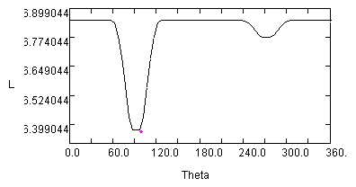
6. Two stars are orbiting one another with an inclination angle of about 1 degree as seen from Earth. They are orbiting one another with a separation of 15 solar radii. Assume that the two stars are main sequence stars.

What are the spectral types of the two stars?

__________ ___________

What are the sizes of the two stars?

__________ ____________

For what range of inclination angles would you not observe a change in brightness of this binary star?

________________________

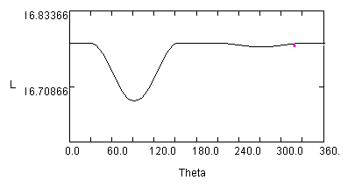
7. A B and a F type star are orbiting one another with a separation of 8 solar radii.

What is the inclination of the orbit if it has the light curve to the right?

________________________

For what range of inclination angles would you not observe a change in brightness of this binary star?

________________________

8. Why would this simple web application (linked above) not be able to simulate a B and a F type star are orbiting one another with a separation of 5 solar radii?

9. List three things that astronomers can learn from a light curve of a binary star?

10. How far is Mars from the Sun at perihelion and aphelion? Clearly show your work.

11. What does CCD stand for?

12. If you purchase a 4 megapixel camera that results in a square image, then what a is the dimension of the photosite array?

______pixels by ________pixels

13. How do you take a “dark frame” image?

14. What is the purpose of “dark frame subtraction”?

15. How do you take a “flat field” image?

16. What is the purpose of taking a “flat field correction”?

Hint: You may use Wikipedia to research “dark frame subtraction” and “flat field correction”.

