Print Your Name : __________________________ Date: _____________

Observing Exercise

Observations of Saturn

Using a pencil, sketch Saturn to scale in the circle representing the eyepiece field of view to the right. Draw what you really see, and not what you expect to see. This should be a neat and realistic drawing.

Draw dots for all the stars that you see around Saturn. Some of these will be moons, so carefully draw dots showing the accurate positions of all star-like objects.

Label North, South, East and West in the ring outside of the field of view. Hint: If you move the telescope north using the hand-paddle, then objects will move south in the eyepiece. And if you move the telescope east (left button) using the hand-paddle, then objects will move west in the eyepiece.

Using the diameter of the planet Saturn as a unit of measure, estimate the diameter of the rings of Saturn. Record your answers below. Hint: Your answer should be greater than 1 and have units of “Saturn Diameters”.

Ring Diameter: ___________________________________

Now estimate the apparent ring height and ring inclination as show in the figure to the right. Include units for your answers. Hint: Your first answer should be less than 1 and have units of “Saturn Diameters”.

Ring Height: ______________________
Ring Diameter

Ring Inclination: _______________
$\text{Inclination}={\text{tan}}^{−1}\left(\frac{\text{ring height}}{\text{ring diameter}}\right)$
Ring Height

1. Use the TheSky software on the classroom computers, the telescope computer, Chapter 10 and Appendix 9 and 11 to answer the questions below about Saturn.

Apparent Magnitude: ________________ Ecliptic Longitude : _________________
Right Ascension : _________________ Declination : _________________
2. In what constellation does Saturn appear tonight? _________________
3. Name a star near Saturn in the sky that is also on your star chart. _________________
4. Using astronomy software at the observatory identify each visible moon of Saturn and label them in your sketch on the first page. Label Titan, Rhea and Dione first. Not all of the other moons will be visible.

5. List the features that you can see on or around Saturn tonight. (Rings, Cassini’s Division, ring shadows, cloud belts, moon shadows, white cyclones, dark streaks, the Great Red Spot, etc.) Stare at Saturn until the seeing is good.

___________________________________________________________________________

___________________________________________________________________________

6. Why does Figure10-13 not represent what you would expect to see through your eyepiece?

___________________________________________________________________________

___________________________________________________________________________

7. Circle the image below that best matches what you observe tonight for Saturn. Note that north is toward the top of this page for the images below.
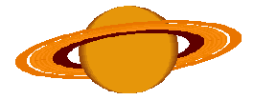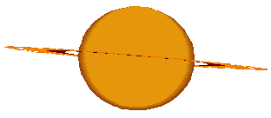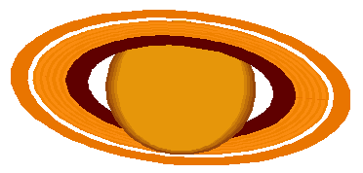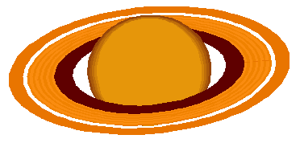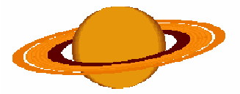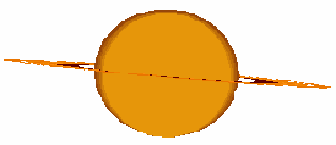

8. In the space below explain why you selected to top row or bottom row in question 7.

