Print Your Name : ____________________________ Local Date of Observation: _____________________

Lab Partner:_____________________________ Local Time: _____________________

Observing Exercise

Telescope Familiarization

In this lab we will become familiar with the various parts of the 8” Meade LX90 telescopes at the SFA Observatory. We will also familiarize ourselves with the manual and automatic operation of this telescope.

1. The Mount: Notice that the telescope that we will be using has an equatorial mount. One axis of rotation points directly to the North Celestial Pole near Polaris. An equatorial mount has two directions of motion, which allow the observer to locate stars on the celestial sphere. These directions are associated with two celestial coordinates:

DECLINATION - North and South on the Celestial Sphere
(toward and away from Polaris)

RIGHT ASCENSION - East and West on the Celestial Sphere
(on a path parallel to the Celestial Equator, hence the name equatorial mount)

2. The Telescope: Become familiar with the different parts of the telescope. Use the user manual of your telescope to find all of these parts:
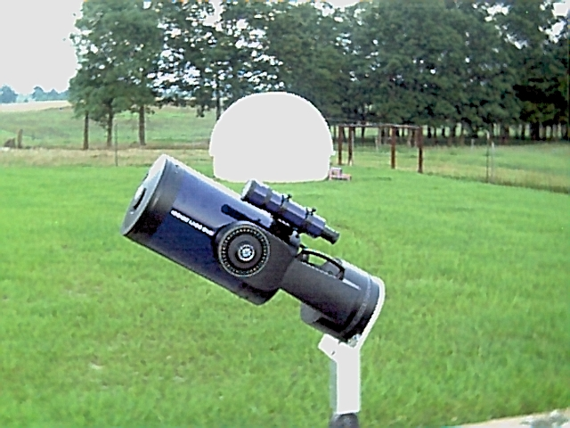
Finder-scope
Focus Knob
Eyepiece
Star Diagonal
Right Ascension Lock
Declination Lock
Primary Mirror
Secondary Mirrors
Corrector Plate
Hand-paddle
Power Cord

Figure 1: The 8” Meade LX90 Telescope

Note: The cloud symbol seen throughout this lab exercise
means that you can still perform the tasks even if it is cloudy.
3. The Finder-scope: The purpose of the finder-scope is to make finding an object in the telescope eyepiece possible. Most of the time the finder-scope will not be pointing in exactly the same direction as the telescope itself. So, at the beginning of each lab you should adjust the screws that hold the finder-scope in place so that the finder-scope and telescope are “lined-up”. The steps required to do this are:

(a) Find a big, bright object such as the Moon, lamp light, red tower light or bright star.

(b) Unlock the Right Ascension and Declination locks.

(c) Point your telescope at the object and move telescope until the object
is in the center of your telescope eyepiece field of view.

(d) Then look in the finder-scope and adjust the finder-scope screws until
the object is in the center of the field of view (use the cross-hairs).

(e) Now make sure that the object is still in the center of the eyepiece
field of view. If not, then center the object again and repeat steps (c) and (d).

After you have aligned the finder-scope with the telescope, show your instructor and get a signature.

Instructor’s Signature: ______________________

4. Manual Operation: Before we begin using the telescope’s internal computer, we will first learn how to manually operate the telescope. Follow these steps when locating the objects below:

(a) Unlock both the right ascension and declination lock knobs.

(b) Use the edge of the 8” telescope tube to roughly site each object.

(c) Center the object in the finder-scope using the crosshairs.

(d) Center the object in the eyepiece of the 8” telescope.

Without using the hand-paddle, manually find the objects below. Your instructor will provide a list of objects.

Object Instructor’s
Name Approval

1st ____________________

2nd____________________

3rd ____________________ ________

4th ____________________

5th ____________________

5. Hand-paddle Operations: Follow the steps below to further prepare your telescope for operation. Put a check in each of the boxes to the left as you complete each task.

The hand-paddle should never be unplugged - even when the telescope is in storage. Leave the hand-paddle plugged into the telescope at all times. The hand-paddle apparently saves information about each telescope, so moving the hand-paddle from one telescope to the next may lead to problems. “Motor Faults” can usually be fixed by resetting the stored data through the appropriate menu option that we will see later. (See Reset under Setup.) See the Instructions Manuals in the file cabinet in the office for more details about your telescope.
Leave the power cords tied up and taped up. You will not need much cord length to reach the telescopes.
Always start with the telescope in the position shown in Figure 1.
Make sure that the hand-paddle is plugged into the fork mount of the telescope and power up the telescope. Note: Make sure that the power cord will not wrap around the mount when the telescope moves.
If a ‘Sun Warning’ appears on the hand-paddle hit 5.
If ‘Getting Started’ appears then press ENTER.
Enter the local date and time when prompted.
Do not proceed with ‘Easy Align’ yet.
Use Table 1 in this handout to make sure that the site is set to LUFKIN. To do this use the MODE and scroll keys to go to the SITE option under the SETUP menu.
Turn off both the ‘Sun Warning’ and ‘Getting Started’ under the DISPLAY OPTIONS under the UTILITIES menu.
Turn on the CORD WRAP feature. This will help prevent the power cord from wrapping around the mount of your telescope.
Make sure that the MOUNT is set to ‘Polar’ rather than ‘AltAz’ in the TELSCOPE option under SETUP.
Point the telescope toward Polaris. The finder-scope should be on top of the telescope as shown on the figure on the first page of this lab exercise. Make sure that the telescope tube is parallel with the fork arms.
Now enter the ALIGN option under the SETUP menu and select ‘Easy’.

Table 1: The Autostar Menu Structure
Object | Event | Guided Tour | Glossary | Utilities | Setup
Solar System | Sunrise | Tonight’s Best | A | Timer | Align
Constellations | Moonrise | How Far is Far | B | Eyepiece Calc. | Date
Deep Sky | Meteor Showers | A Star’s Life | C | Display Options | Telescope
Star | Eclipses |  | D | Cord Wrap | Site
etc. | etc. |  | etc. | etc. | etc.

The telescope will now automatically select two stars to use for calibration. What is the name of the star that the telescope moved to first?

Name of First Star: ________________________________

You can change the motor speed by selecting any of the numbers. ‘1’ for a slow speed, ‘5’ for medium, ‘9’ for fast, etc.
Use the North, South, East and West buttons on your hand-paddle to center this bright star in the eyepiece of your telescope.
When you have centered the star in the eyepiece, press ENTER. The telescope will now automatically move to the second star.

Name of Second Star: _______________________________

Center this bright star in the eyepiece of your telescope. You are now ready for automatic moves to other celestial objects.

7. The Five Brightest Celestial Objects: Locate the five brightest celestial objects in the sky with your telescope and give their coordinates and their visual magnitudes. These objects can include the moon and the planets. Get the coordinates and magnitudes from the screen of the hand-paddle.

Object Right Instructor’s
Name Ascension Declination Magnitude Approval

1st ____________________ _______________ _________________ ____________

2nd____________________ _______________ _________________ ____________

3rd ____________________ _______________ _________________ ____________ ________

4th ____________________ _______________ _________________ ____________

5th ____________________ _______________ _________________ ____________

The magnification of your telescope can be found by taking the focal length of your telescope and dividing it by the focal length of your eyepiece. Look on your telescope and eyepiece to determine these focal lengths. Include units for your answers.

Focal Length of the Telescope: _____________ Focal Length of the Eyepiece: _____________

Magnification of the Telescope: _____________

Give a general description of the sky tonight. Include in your description comments about cloud cover, the phase of the moon, a list of visible planets, and the visibility of the Milky Way galaxy.

If time permits: Allow your telescope to take you on a guided of “Tonight’s Best” objects in the sky. See the GUIDED TOUR menu option. List the names of the objects that you see during your tour in the space below.

__________________________, __________________________, _________________________,

__________________________, __________________________, _________________________

