Print Your Name: ______________________________________ Due on Wednesday, March 7th
(first name) (last name)

Astronomy 305 - In-Class Activity – Mobile App Development

The purpose of this activity is to reinforce the concepts and equations that we have seen so far by developing simple astronomy applications for PC’s and mobile phones.

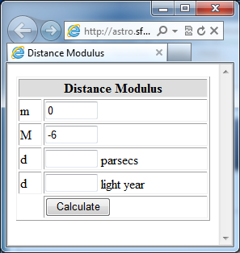
Distance Modulus

1. Go to http://astro.sfasu.edu and click on "Mobile App Dev".
2. Create a new account using your SFA email address.
3. Create a new app with the title of "Distance Modulus".
4. Write JavaScript code that will calculate the distance to an object if you know that absolute magnitude (M) and apparent magnitude (m). Note: d = 10 x 10^{(m-M)/5}
5. Your application should look like the image to the right. Use the code snippets below to get started. You will need to add code to finish this project.

Example Code Snippets:
<html>
<head>
<title> Distance Modulus </title>
<script>

</script>
</head>
<body>
<form>

</form>
</body>
</html>

<table border=1 width=100%>
<tr><th colspan=2 bgcolor=#dddddd>Distance Modulus</th></tr>
<tr><td>m</td><td><input size=5 type=text id=txtAppMag value=0></td></tr>
<tr><td>M</td><td><input size=5 type=text id=txtAbsMag value=-6></td></tr>
<tr><td>d</td><td><input size=5 type=text id=txtd> parsecs</td></tr>
<tr><td> </td><td><input onclick="calc()" type=button value=Calculate></td></tr>
</table>

function calc(){
var AppMag = eval(document.getElementById('txtAppMag').value);
var AbsMag = eval(document.getElementById('txtAbsMag').value);
var d = 10*Math.pow(10,(AppMag - AbsMag)/5);
document.getElementById('txtd').value = d;
alert('Done');
}

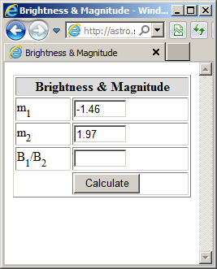
Brightness & Magnitude

1. Create a new app with the title of "Brightness & Magnitude".

2. Write JavaScript code that will calculate the brightness ratio between to celestial objects of magnitude m₁ and m₂.
Note: B₁/B₂ = 2.512^{(m2-m1)}

3. Your application should look like the image to the right. Use the code snippets on the previous exercise to get started.
Use <sub>1</sub> to make subscripts.

Example: Note that m_{Sirius} = -1.46 and m_{Polaris} = 1.97 which means that Sirius is 23.5 times brighter than Polaris.

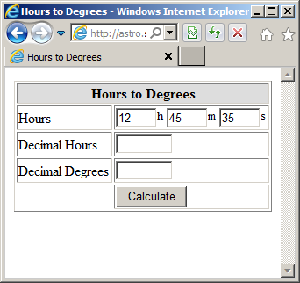
Hours to Degrees

1. Create a new app with the title of "Hours to Degrees".

2. Write JavaScript code that will convert hours, minutes, and seconds to decimal degrees.

3. Your application should look like the image to the right. Use <sup>1</sup> to make superscripts.

