Moon Phase – In-Class Exercise

Write the name of each lunar phase in the blank provided. Do not use your notes or your book for this exercise.

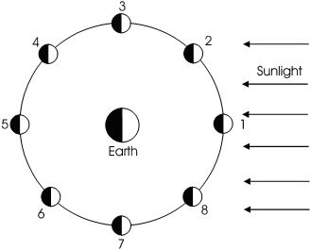
1. _____________________________

2. _____________________________

3. _____________________________

4. _____________________________

5. _____________________________

6. _____________________________

7. _____________________________

8. _____________________________

Write numbers 1 through 8 below each lunar phase below. They are not in the correct order.


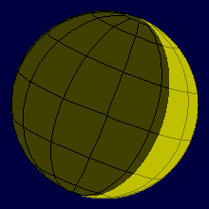
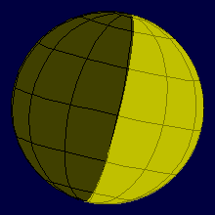
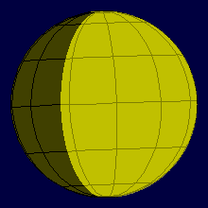



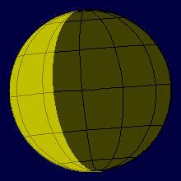

Practical Astronomy with Your Calculator

- Use the steps on page 7 to compute the Julian day for February 10, 2010 at 8pm central time.

________________________________
- What day of the week is February 10, 2014? Use the steps on page 9.

________________________________

- Convert 5^{h}14^{m}67.3^{m} to decimal hours. Then convert it to decimal degrees.

_______________ _________________
- Convert -17.395720º to degrees, arcminutes, and arcseconds.

________________________________
- Convert 12.445620^{h} to hours, minutes, and seconds. Then convert it to decimal degrees.

_______________ _________________

- Convert +49º34’48.3” to decimal degrees.

________________________________

