Print Your Name: ___________________________ Due on April 4th.

Homework 8 - Binary Stars

Use “Practical Astronomy with Your Calculator” and the internet to answer the following questions about binary stars. Use a pencil and write complete sentences. The following web page will help with problem 2 and beyond: http://tinyurl.com/JavaBinaryStars

1. What is meant by “orbital elements”? How many orbital elements are there for a binary star system? List all of them and briefly describe each.

2. Go to http://tinyurl.com/JavaBinaryStars and click "Eclipsing Binary Stars". An F and a G type star are orbiting one another with a separation of 4 solar radii.

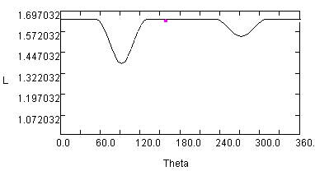
What is the inclination of the orbit if it has the light curve to the right?

________________________

3. Two stars are orbiting one another with an inclination angle of about 1 degree as seen from Earth. They are orbiting one another with a separation of 2 solar radii. Assume that the two stars are main sequence stars.
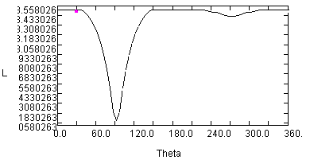

What are the spectral types of the two stars?

__________ ___________

What are the sizes of the two stars?

__________ _____________

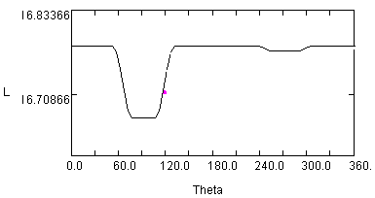4. Two stars are orbiting one another with an inclination angle of about 10 degree as seen from Earth. They are orbiting one another with a separation of 10 solar radii. Assume that the two stars are main sequence stars.

What are the temperatures of the two stars?

__________ _____________

What are the sizes of the two stars?

__________ _____________

5. Two F class stars are orbiting one another with a separation of 10 solar radii. For what range of orbital inclinations will Earth based observers observe no eclipse?

6. Go to http://tinyurl.com/JavaBinaryStars and click "Binary Star System". In the space below make a graph of radial velocity versus time for the following binary star system. Assume that one star has the mass of 2 suns and the other is a 1 solar mass star. Also assume that they orbit one another with an eccentricity of 0.5, with an orbital inclination of 45 degrees, and a longitude of periastron of 45 degrees. Also assume that the semimajor axis length is 2 solar radii. Draw a curve for each star and label each curve with "1 solar mass star" or "2 solar mass star."

Radial Velocity

Time

Is your binary star system above an eclipsing binary star, a spectroscopic binary or both? Explain.

7. Download the photometry data of Beta Lyrae from the homework link on the course home page. Use scatter plots rather than line plots for the graphs below.

Plot #1: Make a plot of apparent magnitude versus Julian Day and staple it to your homework.
i) Label your axes ‘Apparent Magnitude’ and ‘Julian Day’ on your X-Y scatter plot.
ii) Remember to plot the apparent magnitude in reverse order.
This will make ensure that brightness is increasing vertically on your graph.
iii) Use 2449100 to 2449700 in increments of 100 for your Julian Day axis.
iv) Use 3 to 4.5 in increments of 0.5 for your apparent magnitude axis.

Plot #2: Now make plot of apparent magnitude versus orbital phase and staple it to your homework. Orbital phase is the fractional part of (Julian Day - 2448987.54) / 12.93784 in the case of Beta Lyrae. You can enter the following in cell C1 for example: =(A1-2448987.54)/12.93784. To find the factional part of a number in cell C1 in Excel you would enter the following: =C1-INT(C1)
i) Label your axes ‘Apparent Magnitude’ and ‘Orbital Phase’ on your X-Y scatter plot.
ii) Remember to plot the apparent magnitude in reverse order.
iii) Use 0 to 1 in increments of 0.2 for your Orbital Phase axis.
iv) Use 3 to 4.5 in increments of 0.5 for your apparent magnitude axis.

(a) Staple both graphs to this homework.

(b) What is the orbital period of Beta Lyrae? ________________ (include units)

(c) What is the magnitude of Beta Lyrae at the time of primary minimum? _____________

(d) What is the magnitude of Beta Lyrae at the time of secondary minimum? ______________

(e) What is the magnitude of Beta Lyrae at maximum brightness? _______________

(b) Why is Plot #2 more useful than Plot #1. Clearly explain below.

