Print Your Name: ___________________________ Due on Wednesday, February 5th.

Homework Three

Time and the Moon

Use a pencil for all homework. Explain or show your work for each problem for full credit. Read Chapters 8 of Stars and Planets the sections 11 through 16 from the Practical Astronomy book. Use this chapters and sections to answer the questions below.

1. What is the difference between sidereal period and synodic period of the moon? Which corresponds to the time between full moons? Use simple sketches in your explanation.

2. List the eight phases of the Moon starting with the New Moon.

________________________________________________________________________________

On which of the phases listed above would you expect to see earthshine? List all that apply.

________________________________________________________________________________

3. What is the phase of the Moon five days after it is full? __________________________

4. On what day would you expect to see a full Moon this month? ___________________________

5. What is meant by the "limb of the Moon" and the "terminator of the Moon"?

________________________________________________________________________________

________________________________________________________________________________

6. Depending on the phase of the Moon, the frozen lava “seas” on the Moon paint eyes and a mouth on the disk of the Moon. This face is sometimes referred to as “the man on the Moon”.
When the Moon in the sky has a big dark eye that’s…
(a) amore.
(b) a female horse. ANSWER: __________
(c) a moray.
(d) a mare.

7. What is another name for the Sea of Tranquility?______________________________________

8. What is so unusual about the rotation of the Moon about its axis?

________________________________________________________________________________

9. How many people have set foot on the Moon?__________________________

10. What are the names of the first two astronauts to set foot on the Moon?

_________________________________ __________________________________

11. When is the next lunar eclipse? Partial or total? Will it be visible in the United States?

___________________________ ______________ __________________

12. What do scientist think causes the central peaks in craters?

________________________________________________________________________________

13. Does the far side of the Moon have (a) more, (b) less or (c) about the same amount of maria as the near side? Use the photographs in your text.
__________________________
14. Is the far side always dark? Explain.

_______________________________________________________________________________

15. Use Moon Map 7 to answer the following questions. What is the name of the large crater that is just north of Mare Imbrium and appears to be filled with volcanic material (cooled lava)? What is the largest crater that has its rays stretching out across Mare Imbrium on Moon Map 7?

__________________________ __________________________

16. What is the name of the crater with the longest rays on the Moon seen in Figure 8-1?

__________________________

17. "Houston…uh….Tranquility base here….the eagle has landed."
In what lunar "sea" did Apollo 11 land? What is the closest (small, labeled) crater to the Apollo 11 landing site? Which Moon Map did you use to find these answers?

__________________________ __________________________ _________________________

18. Sketch the configuration of the Earth, Sun and Moon for a solar eclipse.

19. Sketch the configuration of the Earth, Sun and Moon for a lunar eclipse.

20. Are you more likely to see a total solar eclipse or a total lunar eclipse during a given year? Explain with complete sentences.

21. The Practical Astronomy book gives some lengthy equations for computing Greenwich mean sidereal time (GST) and local sidereal time (LST). There is an easy way to estimate GST using your SFA Star Charts. GST is simply the right ascension of the meridian at the date and time of interest. For example, in section 12 we see that for April 22, 1980 at 14:36 UT the GST is 4^{h}40^{m}. You can check this using Star Chart 2 for example.

Using your star charts find GST for February 3, 2006 at 2UT and then compute LST.

GST = ________________ LST = __________________

Moon Phase – In-Class Exercise

Write the name of each lunar phase in the blank provided. Do not use your notes or your book for this exercise.

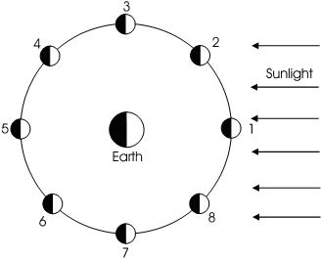
1. _____________________________

2. _____________________________

3. _____________________________

4. _____________________________

5. _____________________________

6. _____________________________

7. _____________________________

8. _____________________________

Write numbers 1 through 8 below each lunar phase below. They are not in the correct order.

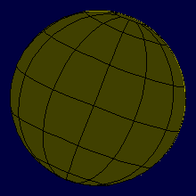
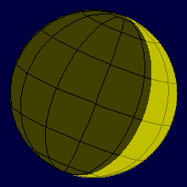
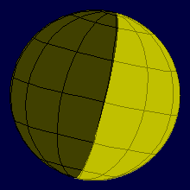
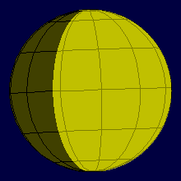
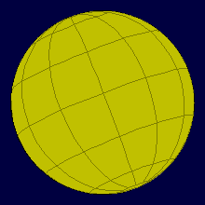
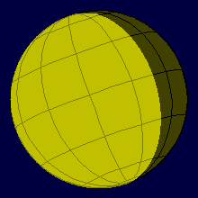
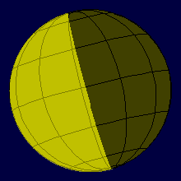
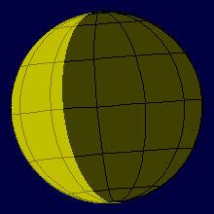

Practical Astronomy with Your Calculator

- Use the steps on page 7 to compute the Julian day for February 10, 2010 at 8pm central time.

________________________________
- What day of the week is February 10, 2014? Use the steps on page 9.

________________________________

- Convert 5^{h}14^{m}67.3^{m} to decimal hours. Then convert it to decimal degrees.

_______________ _________________
- Convert -17.395720º to degrees, arcminutes, and arcseconds.

________________________________
- Convert 12.445620^{h} to hours, minutes, and seconds. Then convert it to decimal degrees.

_______________ _________________

- Convert +49º34’48.3” to decimal degrees.

________________________________

