Print Your Name : __________________________ Date: _____________

Wide Angle CCD Imaging

In the Classroom

You will be imaging 5 sections of the constellation of Leo in this lab exercise using the ST-7E CCD camera with a wide angle lens mounted a 8" telescope. You will work together with your team to create on large image of Leo by piecing together 5 separate images.

Date: _________________ LST at 8:00PM from your Star Chart: _________ LST + 6^{h}: ____

Team Member's Name Section of Leo from the Map Below

___________________________ ___________________________

___________________________ ___________________________

___________________________ ___________________________

___________________________ ___________________________

___________________________ ___________________________

Leo's Head Section

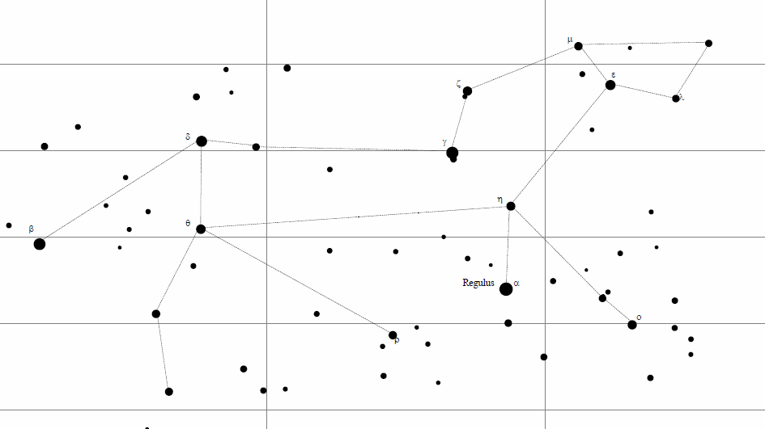
Denebola Section

Front Paw Section
Front Section

Mid Section

Observing

1. Before you begin, watch the "How To" video on the course home page involving the ST-7E CCD camera or use this link: http://tinyurl.com/ST7ECCD

2. With the help of your lab instructor, setup an 8" telescope that has a ST-7E CCD mounting bracket on it.

3. Begin with a section that includes Regulus. Adjust your exposure time so that you have no blooming but lots of stars and very little noise.

4. The images should have stars in focus with very little star drift and no blooming.

5. Make sure that all of your images have the same exposure times. Exposure Time: _________

6. Take 10 images of your section with no automatic dark subtraction.

7. After taking 10 images, get an addition 10 dark images using the same exposure time.

8. Save your images to a jump drive or network drive for later access from the observatory computer lab. You will perform image processing in the computer lab at the observatory.

In the Observatory Computer Lab

1. Load your 10 dark frame images into MaxIM DL and combine all of your dark from images. The select the menu option Process - > Combine... Save the resulting file as CombinedDark.FIT.

2. Now close all of your dark frame images and load all of your sky images. Subtract CombinedDark.FIT from your images using the following menu options:

Process -> Set Calibration -> Select "Dark" -> Click "Add Group"
-> Select "None" for Dark Frame Scaling -> Click Add to select "Dark480.FIT"

Process -> Calibrate All

3. To combine the images into one image they must be aligned with each other. To do this use the following menu selections: Process….Align… Align Mode: “Manual 1 star –shift only”

With your mouse, carefully click on the center of a small star in the first image. The second image should automatically appear. Locate the same star and click on its center as well. Repeat this procedure for all of the images. You will hear a beep when you get to the end. Then click “Ok”.

4. Use the “Screen Stretch” tool to adjust the brightness and contrast of your image
(View->Screen Stretch Window). Crop the image in order to display only the true color part of the image (Edit->Crop). Save your image in JPEG format to the “C:\CCDImages\Yourlastname\” directory. Make sure that you select the “jpg” file format from the pull down menu on the “Save As” window.

Required Filename Format:
YourInitials-YYYYMMDD-ObjectName-ImageNumber.FileExtension

Example: WDB-20100331-LeoRegionName-001.JPG

8. Upload your image using the following link: http://astro.sfasu.edu/grader/upload305.aspx

9. Piece together the 5 images of Leo from your team members using a free program called Paint.Net. Using the example file format below, upload your new image using the link above.

Required Filename Format:
YourInitials-YYYYMMDD-ObjectName-ImageNumber.FileExtension

Example: WDB-20100331-LeoAll-001.JPG

10. Locate Paint.Net on your computer or install this application using the installer located in the Homework -> Extras -> Software folder as a Zip file.

11. Now go back and use Paint.Net to draw the constellation lines for Leo and add labels to your final Leo Team image for the following: Regulus, Denebola, and one Messier Object from Table 12 on page 13.

Using the example file format below, upload your new image using the link above.

Required Filename Format:
YourInitials-YYYYMMDD-ObjectName-ImageNumber.FileExtension

Example: WDB-20100331-LeoLabeled-001.JPG

Important

1. Check to make sure that your image is not all white after you upload it. If your image is all white then save it as a TIFF image first in MaxIM DL and then convert it to a JPG using Irfanview.

2. You will not turn in this page. Grading will be based on the appearance, accuracy, and completeness of the files that you upload to the server.

3. Remember to turn in your homework on top of the Star Box in the classroom.

