Moon Phase Review Your Name:_____________________

Write the name of each lunar phase in the blank provided. Do not use your notes or your book for this exercise.

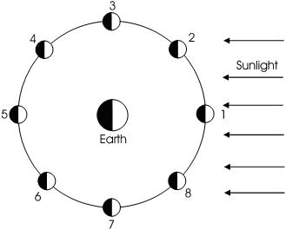
1. _____________________________

2. _____________________________

3. _____________________________

4. _____________________________

5. _____________________________

6. _____________________________

7. _____________________________

8. _____________________________

Write numbers 1 through 8 below each lunar phase below.










Practical Astronomy with Your Calculator

- Use the steps on page 7 to compute the Julian day for October 10, 1995 at 6am.

________________________________
- What day of the week was October 10, 1995? Use the steps on page 9.

________________________________

- Convert 5^{h}14^{m}67.3^{m} to decimal hours. Then convert it to decimal degrees.

_______________ _________________

- Convert -17.395720º to degrees, arcminutes, and arcseconds.

________________________________

