Print Your Name : __________________________ Date: _____________

Observing Exercise

Observations of Saturn

Using a pencil, sketch Saturn to scale in the circle representing the eyepiece field of view to the right. Draw what you really see, and not what you expect to see. (15 points)

Using astronomy software at the observatory identify each visible moon of Saturn and label them in your sketch to the right. Not all moons will be visible. (5 points)

Label North, South, East and West in the ring outside of the field of view. Hint: If you move the telescope north using the hand-paddle, then objects will move south in the eyepiece. And if you move the telescope east (left button) using the hand-paddle, then objects will move west in the eyepiece. (5 points)

Using the diameter of the planet Saturn as a unit of measure, estimate the diameter of the rings of Saturn. Record your answers below. Hint: Your answer should be greater than 1 and have units of “Saturn Diameters”. (5 points)

Ring Diameter: ________________________________

Now estimate the apparent ring height and calculate the ring inclination using the figure to the right. (5 points)

Ring Height: _______________________________
Ring Diameter

Ring Inclination: _______________
$\text{Inclination}={\text{tan}}^{−1}\left(\frac{\text{ring height}}{\text{ring diameter}}\right)$
Ring Height

6. Using your telescope computer, Chapter 10, and Appendix 9 and 11 to answer the questions below. Include units. (5 points)

Apparent Magnitude: ____________ Right Ascension :_____________ Declination : ___________ Ecliptic Longitude: __________
7. In what constellation does Saturn appear tonight? (5 points) _________________________
8. Give the Bayer designation of a star near Saturn in the sky that is also on your star chart. (5 points) _________________________
9. List any features that you can see on or around Saturn tonight. (Rings, Cassini’s Division, ring shadows, cloud belts, moon shadows, white cyclones, dark streaks, etc.) Stare at Saturn until the seeing is good. (5 points)

_________________________________________________________________________________________________________

_________________________________________________________________________________________________________

10. Why does Figure10-13 not represent what you would expect to see through your eyepiece? (5 points)

__________________________________________________________________________________________________________

11. The tilt of Saturn’s rings as seen from Earth changes as Saturn and the Earth orbit the Sun. The images below are a few examples of the views of Saturn that we can expect to see from Earth. Circle the image below that best matches what you observe tonight for Saturn. Note that north is toward the top of this page for the images below. (5 points)

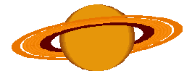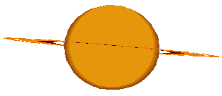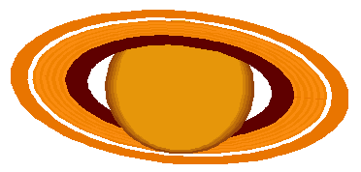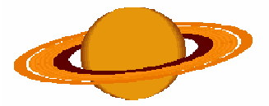

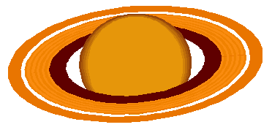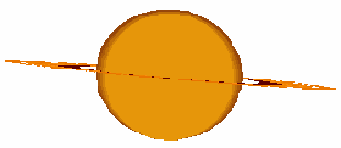

12. Astronomers are able to measure the mass of planets using measured orbital distances and orbital periods of moons. Kepler’s laws not only works for the orbit of planets around the Sun, but also accurately describes the orbits of moons around their hosts. Kepler’s third law is
$$P^{2}=\frac{4π^{2}}{G}⋅\frac{a^{3}}{\left(m+M\right)}$$

where m and M are the masses of the moon and the planet respectively, P is the period of the orbit, G is the universal gravitational constant (6.672 x 10⁻¹¹ Nm²/kg²), and a is the semi-major axis. Note that the m>>M for most planet-moon systems. For this reason we can approximate (m + M) as simply M.

Complete the table below for the moons that you were able to observe tonight. Leave any remaining rows blank. Start with the brightest moon in your list. Use the Appendix of your book to find P and a. Use scientific notation for large numbers. (10 points)

Name | Magnitude | P (days) | P (seconds) | P² (s²) | a (meters) | a³ (m³)

13. Use Microsoft Excel to make a scatter plot of P² versus a³. See the help menu or your instructor if you are not familiar with Excel.
(10 points)

- Label the axes and include units for each axis.
- Include the title “Data for Saturn’s Moons” at the top of the plot.
- Add a trend line through your data using Excel and display the equation of this line on your chart.
- Staple a printout of your chart to this lab.

14. Use the slope of your line and Kepler’s third law to calculate the mass of Saturn. Show your work clearly in the space below. Include units for your answers. (15 points)

Slope = ________________

Computed Mass of Saturn = ________________

Percent Error = ________________

