Print Your Name: ___________________________ Due on April 7th.

Homework 10 - More on Binary Stars

Use “Practical Astronomy with Your Calculator” and the internet to answer the following questions about binary stars. Use a pencil and write complete sentences. This web page will help http://instruct1.cit.cornell.edu/courses/astro101/java/simulations.htm

1. What is meant by “orbital elements”? How many orbital elements are there for a binary star system? List all of them and briefly describe each.

2. An F and a G type star are orbiting one another with a separation of 4 solar radii.

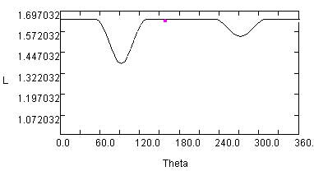
What is the inclination of the orbit if it has the light curve to the right?

____________________

What are the sizes of the two stars?

_____________________

_____________________

3. Two stars are orbiting one another with an inclination angle of about 1 degree as seen from Earth. They are orbiting one another with a separation of 2 solar radii. Assume that the two stars are main sequence stars.
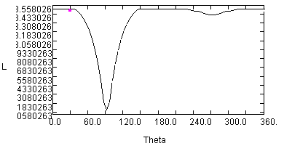

What are the spectral types of the two stars?

__________ _________

What are the sizes of the two stars?

_____________________

_____________________

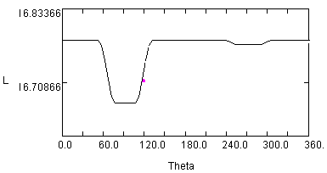4. Two stars are orbiting one another with an inclination angle of about 10 degree as seen from Earth. They are orbiting one another with a separation of 10 solar radii. Assume that the two stars are main sequence stars.

What are the temperatures of the two stars?

_____________________

_____________________

What are the sizes of the two stars?

_____________________

_____________________

5. Two F class stars are orbiting one another with a separation of 10 solar radii. For what range of orbital inclinations will Earth based observers observe no eclipse?

_____________ to _____________

6. In the space below make a graph of radial velocity versus time for a binary star system. Draw a curve for each star. Assume that one star has the mass of 2 suns and the other is a 1 solar mass star. Also assume that they orbit one another with an eccentricity of 0.5, with an orbital inclination of 45 degrees, and a longitude of periastron of 45 degrees. Also assume that the semimajor axis length is 2 solar radii.

Is this binary star system above an eclipsing binary star, a spectroscopic binary or both? Explain.

7. Download the photometry data of Beta Lyrae from the homework link on the course home page.

(a) Make a plot of apparent magnitude versus Julian Day and staple it to your homework.

(b) Make a plot of apparent magnitude versus orbital phase and staple it to your homework.

(c) Orbital phase is the fractional part of (Julian Day - 2448987.54) / 12.93784 in the case of Beta Lyrae.

(d) Why is the plot in part (b) more useful than the plot in part (a)?

__________________________________________________________________________

(e) What is the orbital period of Beta Lyrae?

____________________________

(f) What is the magnitude of Beta Lyrae at the time of primary minimum?

____________________________

(g) What is the magnitude of Beta Lyrae at the time of secondary minimum?

____________________________

(h) What is the magnitude of Beta Lyrae at maximum brightness?

____________________________

