Print Your Name : ____________________________ Local Date of Observation: _____________________
Lab Partner:_____________________________ Local Time: _____________________

Observing Exercise

Double Stars - Stars and Planets: Chapter 6

When we look at the night sky, most of the stars we see seem to be single points of light. However more detailed investigation has revealed that most of the stars in our galaxy are actually in double star systems - systems containing two or more stars. The period with which the components of double star systems orbit each other range from hours up through centuries. In this lab we will locate several double star systems and examine them with our telescopes.

Starting Up: Please follow these steps carefully to avoid damage to the telescope and its electronics. Put a check in each of the boxes to the left as you complete each task.

Attach the telescope to its mount using a single bolt with a knob.
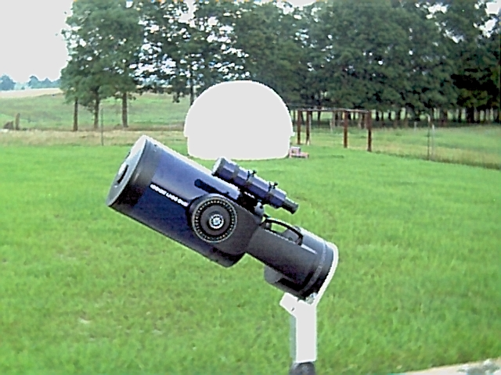
Plug the hand-paddle into the fork mount of the telescope and power up the telescope.
Make sure that the power cord will not wrap around the mount when the telescope moves.
Remove all of the dust covers and lens caps and store them on the ground on the south side of the mount.
Use a streetlight to make sure that the finderscope and telescope are pointed in the same direction.

Table 1: The Autostar Menu Structure
Object | Event | Guided Tour | Glossary | Utilities | Setup
Solar System | Sunrise | Tonight’s Best | A | Timer | Align
Constellations | Moonrise | How Far is Far | B | Eyepiece Calc. | Date
Deep Sky | Meteor Showers | A Star’s Life | C | Display Options | Telescope
Star | Eclipses |  | D | Cord Wrap | Site
etc. | etc. |  | etc. | etc. | etc.

The Hand-paddle: The manual for the telescope refers to the hand-paddle as the Autostar Handbox. Follow the steps below to further prepare your telescope for operation. Put a check in each of the boxes to the left as you complete each task.
If a ‘Sun Warning’ appears on the hand-paddle hit 5.
If ‘Getting Started’ appears then press ENTER.
Enter the local date and time when prompted.
Proceed with ‘Easy Align’ when prompted.
The telescope will now automatically select two stars to use for calibration. What is the name of the star that the telescope moved to first?
Name of First Star: ________________________________

Use the North, South, East and West buttons on your hand-paddle to center this bright star in the eyepiece of your telescope.
You can change the motor speed by selecting any of the numbers. ‘1’ for a slow speed, ‘5’ for medium, ‘9’ for fast, etc.
When you have centered the star in the eyepiece, press ENTER. The telescope will now automatically move to the second star.
Name of Second Star: _______________________________

Finding Double Stars: Using your star charts and the list of double stars in Appendix 6 on page 530-531 of Stars and Planets, list the Bayer Designations of ten double stars that are above the horizon now. A few examples are shown below.

Bayer Designations Magnitudes Angular Separations Your Rank† Approval‡

______β Ori______ _________ _________ _________ __________

______θ¹ Ori_____ _________ _________ _________ __________

______λ Ori______ _________ _________ _________ __________

______σ Ori______ _________ _________ _________ __________

________________ _________ _________ _________ __________ ___________

________________ _________ _________ _________ __________

________________ _________ _________ _________ __________

________________ _________ _________ _________ __________

________________ _________ _________ _________ __________

________________ _________ _________ _________ __________

†Rank the double stars above from 1 to 10 with 1 being the easiest to resolve and 10 being the most difficult.
‡Show your instructor your 8th place double star and get your instructor’s approval (signature) above.

Which of the double stars above have noticeable color differences between the two stars of the system?

_____________________________________________________________________________________

Dawes’ Limit: A nineteenth-century English Astronomer, William Dawes worked out a rule of thumb to give the telescope aperture (diameter of the lens or mirror) necessary to separate (resolve) double stars into their components, that is, to tell that two stars are present in a system. His rule is that an aperture of d inches should make barely detectable the presence of a pair of 6th magnitude stars separated by 4.6/d seconds of arc(′). Dawes’s rule assumes good sky conditions for viewing and that the stars are not too different in magnitude.

Focal Length of the Telescope: ______________________
Focal Length of the Eyepiece: ______________________
Magnification of the Telescope: _____________________

What is Dawes’s Limit for your telescope? Include units for your answer. ___________________

Look again at the list of double stars in Appendix 6 on page 530-531 of Stars and Planets. Do any of the double stars in that list have separations that are below Dawes’s Limit? ____________

What is the Bayer Designation of the double star Appendix 6 that is most difficult to resolve? _____________

Double Stars and Variable Stars:
Briefly define these Double Stars:
Visual Binary
Eclipsing Binary
Spectroscopic Binary
Astrometric Binary
Optical Doubles

Briefly define these Variable Stars

Mira Variable
RR Lyrae Variable
Cepheid Variable
Flare Stars

Which of the double stars above is also a variable star? ______________________________

Most of the stars in Appendix 6 belong to what two classes of double stars above?

_____________________________ and _____________________________

