Print Your Name: ___________________________ Due on May 5th.

Homework 10 - More on Binary Stars

Use “Practical Astronomy with Your Calculator” and the internet to answer the following questions about binary stars. Use a pencil and write complete sentences. This web page will help http://instruct1.cit.cornell.edu/courses/astro101/java/simulations.htm

1. What is meant by “orbital elements”? How many orbital elements are there for a binary star system? List all of them and briefly describe each.

2. An F and a G type star are orbiting one another with a separation of 4 solar radii.

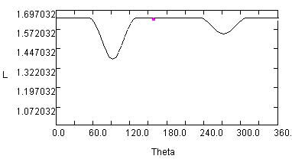
What is the inclination of the orbit if it has the light curve to the right?

3. Two stars are orbiting one another with an inclination angle of about 1 degree as seen from Earth. They are orbiting one another with a separation of 2 solar radii. Assume that the two stars are main sequence stars.
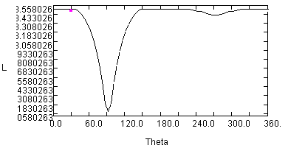

What are the spectral types of the two stars?

What are the sizes of the two stars?

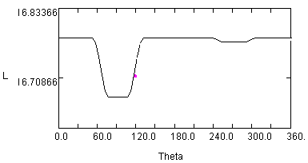4. Two stars are orbiting one another with an inclination angle of about 10 degree as seen from Earth. They are orbiting one another with a separation of 10 solar radii. Assume that the two stars are main sequence stars.

What are the temperatures of the two stars?

What are the sizes of the two stars?

5. Two F class stars are orbiting one another with a separation of 10 solar radii. For what range of orbital inclinations will Earth based observers observe no eclipse?

6. In the space below make a graph of radial velocity versus time for a binary star system. Draw a curve for each star. Assume that one star has the mass of 2 suns and the other is a 1 solar mass star. Also assume that they orbit one another with an eccentricity of 0.5, with an orbital inclination of 45 degrees, and a longitude of periastron of 45 degrees. Also assume that the semimajor axis length is 2 solar radii.

Is your binary star system above an eclipsing binary star, a spectroscopic binary or both?

7. Download the photometry data of Beta Lyrae from the homework link on the course home page.

(a) Make a plot of apparent magnitude versus Julian Day and staple it to your homework.

(b) Make a plot of apparent magnitude versus orbital phase and staple it to your homework. Orbital phase is the fractional part of (Julian Day - 2448987.54) / 12.93784 in the case of Beta Lyrae.

(c) Why is the plot in part (b) more useful than the plot in part (a)?

(d) What is the orbital period of Beta Lyrae?

(e) What is the magnitude of Beta Lyrae at the time of primary minimum?

(f) What is the magnitude of Beta Lyrae at the time of secondary minimum?

(g) What is the magnitude of Beta Lyrae at maximum brightness?

