Name: ____________________________

The Visible Planets (v.2018)

Discussion
On the following pages of this experiment, you will find diagrams of the orbits of the visible planets. The first of these diagrams shows the position of the sun with the orbits of Mercury, Venus, Earth, and Mars. The second sheet has a scale so that both the orbits of Jupiter and Saturn can be seen. On the chart showing the orbits Mercury, Venus, Earth, and Mars you will notice the orbits of Mars and Mercury are much more elliptical than the orbits of Venus and the Earth. We say that these two planets have orbits with large eccentricity. Another feature of this diagram is that it shows that the orbits of these planets are inclined to the ecliptic. When the orbit of the planet extends above the plane of the Earth's orbit, the orbit is drawn as a solid line. When the orbit extends below the orbit of the Earth, the orbit is shown as a broken line. Notice that except for the orbit of the Earth all of the other orbits have a series of fractions that go in a counterclockwise direction from an arbitrary zero for each orbit. By utilizing a set of decimal values for each of the planets, it is possible to locate the decimal position of any planet between the years 1400 and 2400 A.D. In the case of the Earth it is simply a matter of locating the month and estimating within the month the nearest position of the Earth along the Earth's orbit.
In this experiment you will use the tables found on pages 6-8 to locate the planets on today's date and also for the date of your birth. The location of the planets on the date of your birth is called your natal horoscope.

How to Find the Positions of the Planets
As an example of how to find the positions of the planets for an arbitrary day, we will use the date July 20, 1998 and find the location of the planets on this date. Refer to the table labeled Decimals for Plotting Orbital Position of the Planets (pages 6-8). You will notice on this table that there are five major columns. The first column corresponds to the first two digits of the year, the second column corresponds to the third digit of the year, and the third column corresponds to the fourth digit of the year. The next column is used for the month and the final column corresponds to the day.

Date: July 20, 1998
 | Mercury | Jupiter | Venus | Mars | Saturn
Year in Hundreds: 19 | .00 | .00
Year in Tens: 9 | .68 | .59
Year in Units: 8 | .22 | .67
Month: July | .35 | .65
Day: 20 | .215
Sum | 1.465 | 1.91 | 0.765 | 1.28 | 0.83
The table above shows the details for the example date for the planets Mercury and Jupiter. Use the tables on pages 6-8 to find the entries above. Consider Jupiter first. It moves slowly enough that it is accurately positioned by simply knowing the month and year. The entry for the day, therefore, is left blank. Mercury moves much more quickly and the days column must be used. The example date of July 20 forces us to interpolate between entries to get the entry of .215.
The procedure calls for us to sum the entries for each planet. You may discard the number to the left of the decimal point. Only the decimal portion of the sum is useful in locating the planet. Now turn to the diagram at the end of this experiment that shows the orbits of Jupiter and Saturn. Along the orbit of Jupiter you will find the numbers .9 and .0. The number you obtained for the position of Jupiter was .91. This number lies between .9 and .0 on the chart. Estimate the location of Jupiter on the date July 20, 1998.
The other orbital diagram shows the orbits of the inner four planets. On the orbit of Mercury, find the decimals .4 and .5. In our example the position for Mercury was .465, which is 65% of the way between .4 and .5.
One does not need the use of these tables in order to locate the Earth on any given date. Simply locate that section of the Earth's orbit labeled for the particular month in question, in our example, July. Then estimate as well as you can the nearest day along the sector corresponding to the month. July the 20th occurs two-thirds of the way from the beginning of the month to the end of the month. As a check you should follow the preceding procedure for the planets Venus, Mars, and Saturn. For these planets you should obtain the values given in the table. If you have obtained the values for the planets as given in this example, then you are ready to plot the positions of the planets on any date of your choosing.

Procedure for Finding the Position of the Planets Today
1. Enter today's date in the table below. Locate the decimals for each planet and enter them and their sum in the space provided.

Today’s Date: | Mercury | Venus | Mars | Jupiter | Saturn
Year in Hundreds:
Year in Tens:
Year in Units:
Month:
Day:
Sum

Your Birthday: | Mercury | Venus | Mars | Jupiter | Saturn
Year in Hundreds:
Year in Tens:
Year in Units:
Month:
Day:
Sum

2. Plot your results for today’s date on the two graphs labeled “Today’s Date”.
3. Now plot your results for your birthday on the two graphs labeled “Your Birthday”.

How to Locate the Planets in the Zodiac.
Throughout the year the sun appears to move with respect to the stars. At the end of the year the sun returns to the same location that it had at the beginning of the year. The imaginary path that the sun takes across the sky throughout the course of the year is called the ecliptic. There are twelve constellations along this path named by ancient civilizations. We now call these constellations the signs of the Zodiac. These are the constellations like Pisces, Taurus, Virgo and the others. Since there are twelve of these constellations and three hundred and sixty degrees in a circle, each of these constellations subtends approximately 30 degrees of the nighttime sky. The position of these constellations along the ecliptic can be used as a crude coordinate system whereby planets and other celestial objects can be located. For instance, one can locate a particular planet by saying this planet is located in the constellation Leo or the constellation Scorpio. For most viewing work with small telescopes, this is a sufficiently accurate coordinate system to locate most objects.
A more accurate scale along the ecliptic can be used. This amounts to breaking up the ecliptic path into a total of 360 degrees. The zero degree direction for this path is located along the line which points from the earth to the sun and then on to the constellation Pisces on March 21 of any year (the direction to the Vernal Equinox). If you will refer to the table entitled "Angular Sectors of the Zodiacal Constellations" you will note that Pisces is located in the general direction of zero degrees. This chart also uses the actual extent of each constellation along the ecliptic. For instance you will notice that Pisces subtends an angle from 350 degrees to 30 degrees along the ecliptic. Scorpio subtends the smallest angle across the ecliptic.
You will notice that the Zodiac Constellations are labeled around the scale on each of the 4 graphs.

Procedure for Finding the Planet's Constellation
1. Locate the graph with the circular scale on page 13.
2. Use the Angular Sectors of the Zodiacal Constellations found on page 12 to draw lines emanating from the Earth on page 13 along the angles that divide the Zodiacal signs.

3. Label each of the subsequent sectors according to the Zodiacal sign which subtends that angle.
4. Lay this piece of paper over the plot of the location of the planets for some date. Place the center of this paper over the position of the Earth. Make sure the zero degree direction for the Zodiacal coordinate system lies parallel to the zero degree line on the chart representing the position of the planets.
5. You will note that the planets will fall within certain sectors corresponding to each of the Zodiacal signs. As seen from the Earth this is the Zodiacal constellation in which this planet will be found.
6. Record in the following spaces the location of each of the planets for today's date.

Today’s Date
Planet | Constellation | Planet | Constellation
Mercury |  | Jupiter
Venus |  | Saturn
Mars |  | Sun

7. Record in the following spaces the location of each of the planets for your birthday.
Your Birthday
Planet | Constellation | Planet | Constellation
Mercury |  | Jupiter
Venus |  | Saturn
Mars |  | Sun

Decimals for Plotting Orbital Positions of the Planets
1400 to 2399 AD.

Year - Hundreds Year - Tens
 | Mer | Ven | Mar | Jup | Sat |  | Mer | Ven | Mar | Jup | Sat
14 | .02 | .29 | .18 | .85 | .02 | 0 | .00 | .00 | .00 | .00 | .00
15 | .22 | .82 | .23 | .28 | .42 | 1 | .52 | .25 | .31 | .94 | .33
16 | .41 | .36 | .51 | .71 | .82 | 2 | .04 | .51 | .63 | .69 | .68
17 | .61 | .91 | .67 | .14 | .21 | 3 | .56 | .76 | .95 | .53 | .02
18 | .80 | .45 | .84 | .57 | .61 | 4 | .08 | .01 | .27 | .37 | .35
19 | .00 | .00 | .00 | .00 | .00 | 5 | .60 | .27 | .58 | .22 | .70
20 | .20 | .55 | .16 | .43 | .39 | 6 | .12 | .53 | .90 | .06 | .04
21 | .39 | .09 | .33 | .86 | .79 | 7 | .64 | .78 | .21 | .90 | .38
22 | .59 | .64 | .49 | .29 | .18 | 8 | .16 | .04 | .53 | .74 | .72
23 | .78 | .18 | .66 | .72 | .58 | 9 | .68 | .29 | .85 | .59 | .06

Year - Units
 | Mer | Ven | Mar | Jup | Sat
0 | .00 | .00 | .00 | .00 | .00
1 | .15 | .63 | .53 | .08 | .03
2 | .30 | .25 | .06 | .17 | .07
3 | .46 | .88 | .59 | .25 | .10
4 | .61 | .50 | .13 | .34 | .14
5 | .76 | .13 | .66 | .42 | .17
6 | .91 | .75 | .19 | .51 | .20
7 | .06 | .38 | .72 | .59 | .24
8 | .22 | .00 | .25 | .67 | .27
9 | .37 | .63 | .78 | .76 | .31

Continued on the next page…

Months Days
 | Mer | Ven | Mar | Jup | Sat |  | Mer | Ven | Mar
Jan | .29 | .58 | .90 | .61 | .49 | 1 | .00 | .00 | .00
Feb | .64 | .72 | .95 | .62 | .49 | 3 | .02 | .01 | .00
Mar | .96 | .85 | .99 | .62 | .49 | 5 | .05 | .02 | .01
Apr | .31 | .99 | .03 | .63 | .50 | 7 | .07 | .03 | .01
May | .65 | .12 | .07 | .64 | .50 | 9 | .09 | .04 | .01
Jun | .00 | .26 | .11 | .65 | .50 | 11 | .11 | .05 | .02
Jul | .35 | .39 | .15 | .65 | .50 | 13 | .14 | .05 | .02
Aug | .70 | .53 | .20 | .66 | .51 | 15 | .16 | .06 | .02
Sep | .06 | .67 | .25 | .66 | .51 | 17 | .18 | .07 | .03
Oct | .40 | .80 | .29 | .67 | .51 | 19 | .20 | .08 | .03
Nov | .75 | .94 | .34 | .68 | .52 | 21 | .23 | .09 | .03
Dec | .09 | .07 | .38 | .68 | .52 | 23 | .25 | .10 | .03
 |  |  |  |  |  | 25 | .27 | .11 | .04
 |  |  |  |  |  | 27 | .30 | .12 | .04
 |  |  |  |  |  | 39 | .32 | .13 | .04
 |  |  |  |  |  | 31 | .34 | .13 | .04

Today’s Date
Mercury through Mars

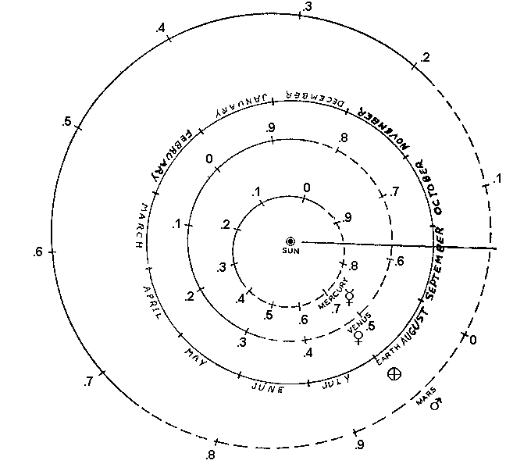

Today’s Date
Jupiter and Saturn
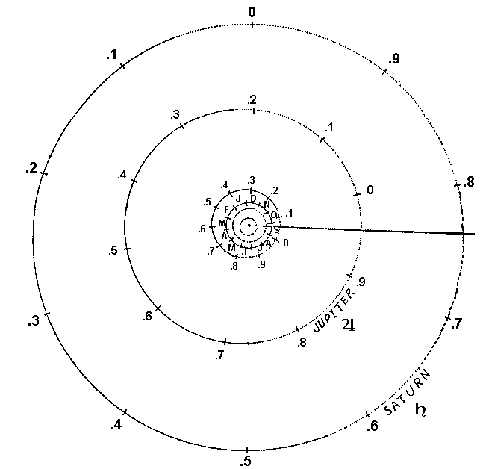

Your Birthday
Mercury through Mars

Your Birthday
Jupiter and Saturn

Angular Sectors of the
Zodiacal Constellations

Degrees | Zodiacal | Symbol
 | Constellation
350
 | Pisces
30
 | Aries
52
 | Taurus
90
 | Gemini
117
 | Cancer
137
 | Leo
173
 | Virgo
217
 | Libra
240
 | Scorpio
265
 | Sagittarius
290
 | Capricorn
326
 | Aquarius
350

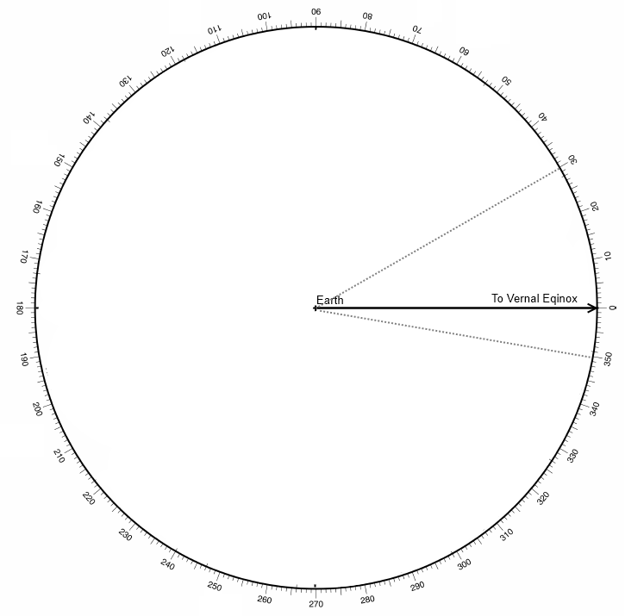
Pisces

