Print Your Name: ___________________________

CLEA - Hubble’s Law
Important: If you completed the Saturn and Jupiter Lab on Saturday morning,
then you do not need to complete this lab activity.

The goal of the exercise is to be able to find the relationship between the redshift in spectra of distant galaxies and the rate of the expansion of the universe.

Procedure

1. If you have not already done so, install the “VIREO Software” using the link on the D2L course page for Astronomy 305. You will need to unzip the file and then run the installer. You may need to right clicking on the installer and run the installer as an administrator of your computer.

2. If you need help completing the data sheet on page 2 then refer to this document: https://goo.gl/okHM8J

3. Use the data sheet on page 2 above to make a graph of Velocity (AVG) versus the Distance in parsecs. Complete the graph below and answer the questions on page 3.

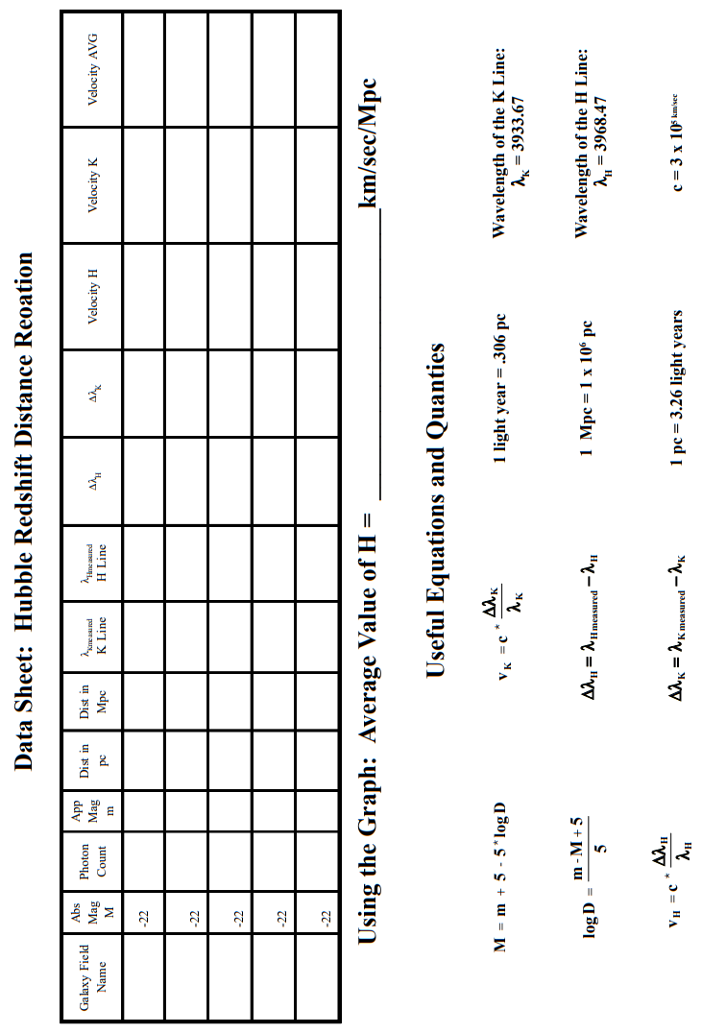
Questions

Compute the slope of the best-fit line for the graph. This slope is called the Hubble constant, H. Include units for your answer.

H = _______________________________

What does Hubble's Law tell us about our universe?

Compute the "radius" and "age" of the universe in lightyears and years respectively. Show your work in the space provided. Hint: See the instruction link provided on Procedure 2 on page 1 of this handout.

Radius = ___________________________ Age = ____________________________

