Astronomical Imaging - Moon
Name: ______________________
You will not turn in this page. Grading will be based on the appearance, accuracy,
and completeness of the files that you upload.

Eyepiece Projection with a Camera or Smartphone

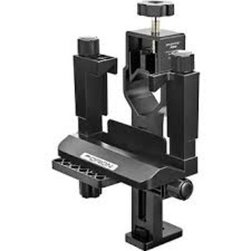
1. With the help of your lab instructor, setup a telescope with a SteadyPix Pro Camera/Smartphone Mount.
SteadyPix Pro Camera/Smartphone Mount

2. Select a bright target such as one of the following objects:
(a) Jupiter or Saturn
(b) Craters near the Terminator of the Moon
(c) Bright Star Clusters or Bright Nebulae
(d) Distant streetlights (if it is cloudy)

3. Using the adjustment screws position your smartphone or camera so that it is looking directly through the clamp that will be clamped around the eyepiece of the telescope.

4. Carefully focus the telescope and take enough images so that you have at least one image that is in focus and has not drifting objects (i.e. no streaks).

5. Transfer the image from your smartphone or camera to one of the computers at the observatory.

6. Login to your Google Site account and click on the "New Page" button to add a page for this image. Be sure the give the page a title that is relevant to the object that you imaged. This page should appear above or below your Sitemap link for your "Astronomy 305 – YourLastName" web site. Make sure that you describe your image on the web page (date, time, telescope, exposure time, etc.). An example description is given below.

Smartphone Image – Moon

Time: March 30, 2020 @ 8:45PM
Telescope: 16" at the SFA Observatory
Camera: iPhone 5
App: Apple Camera App
Exposure Time: Automatic

