Print Your Name: ___________________________

CLEA - Photoelectric Photometry of the Pleiades

Data Collection

1. Install the “VIREO Software” using the link on the D2L course page for Astronomy 305. You will need to unzip the file and then run the installer. You may need to right clicking on the installer and run the installer as an administrator of your computer.

2. Launch “VIREO” under the “CLEA” found under the Windows Start Menu (Programs). Log in to the application and enter your student information. Click “Run” and familiarize yourself with the controls using this video tutorial.

3. Open the observatory and locate the star that is assigned to you at www.goo.gl/pvoPXZ. Note that the coordinates for your star can be found on page 2 of this document. Take “sky” counts. Take “star” readings, and record your results below.

Your Star Number: _______ RA: __________________ DEC: __________________

B: _________ V: _______ B-V: __________

Absolute |  | Spectral
Magnitude (M) | B-V | Type
-5.8 | -0.35 | O5
-4.1 | -0.31 | BO
-1.1 | -0.16 | B5
-0.7 | 0 | AO
2 | 0.13 | A5
2.6 | 0.27 | F0
3.4 | 0.42 | F5
4.4 | 0.58 | GO
5.1 | 0.7 | G5
5.9 | 0.89 | KO
7.3 | 1.18 | K5
9 | 1.45 | MO
11.8 | 1.63 | M5
16 | 1.8 | M8

Graph #1: Main Sequence Stars

4. The table to the right provides data for main sequence stars. Note that the variable “M” is the absolute magnitude. Plot the data from the table on the “Absolute Magnitude versus Color Index” graph on page 3.

5. Use your graph from part 4 above and the value of B-V for your star to estimate the absolute magnitude of your star (M). Use the visual magnitude (V) for your apparent magnitude (m). Find the distance to your star in parsecs using the equation below.

M = ______ m = ______ d = 10 x 10^{(m-M)/5} = ________parsecs

Graph #2: The Stars of the Pleiades

7. Complete the table on page 2 using the data collected by you and your classmates.

8. Plot the V column versus the B-V column for the “Apparent Magnitude versus Color Index” graph on page 5.

9. Overlay your two graphs to find an average value of (m-M). Calculate the distance to the cluster in parsecs. Then convert your answer to light years. Note that 1 parsec = 3.26 light years.

m - M = _________________(from graph overlay)

Distance to the Pleiades: _________________parsecs

Distance to the Pleiades: _________________light years

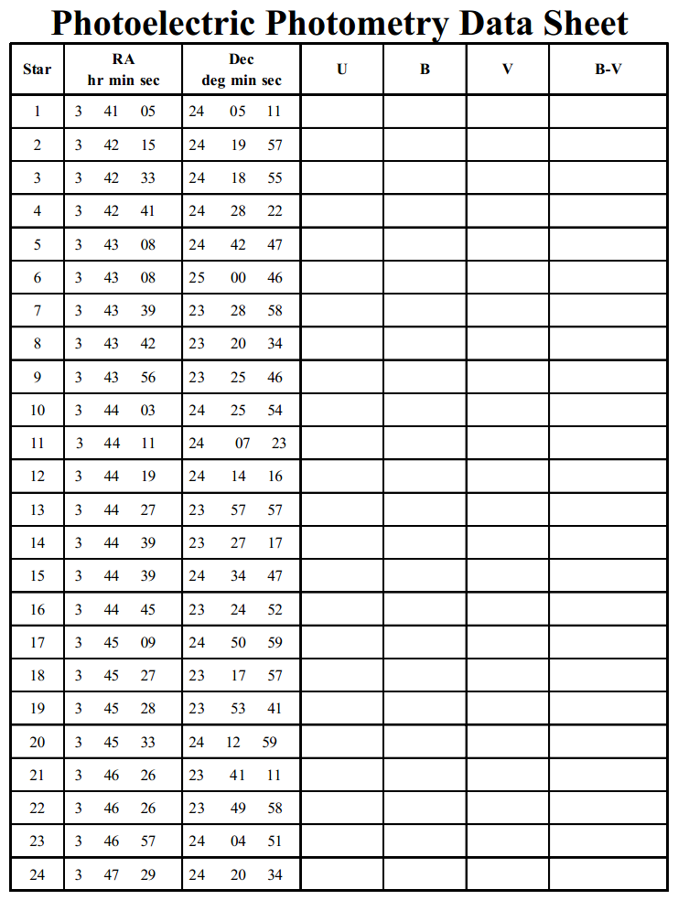

Main Sequence Stars

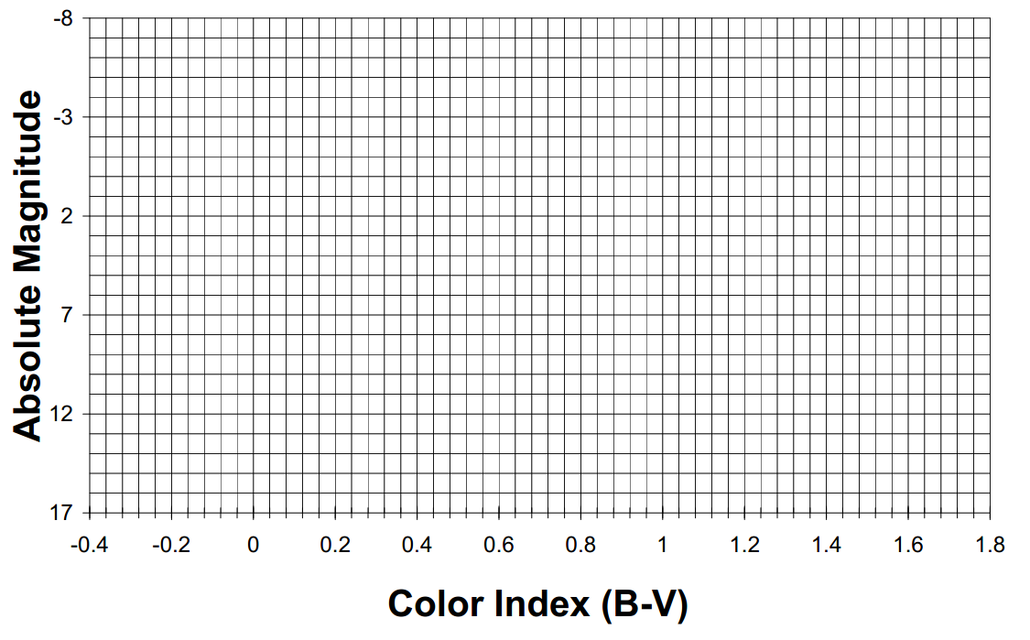

The Stars of the Pleiades
