Print Your Name: __________________________

Eclipsing Binary Stars
Indoor Activity

In astronomy, stellar classification is the classification of stars based on their spectral characteristics. Most stars are currently classified under the Morgan-Keenan (MK) system using the letters O, B, A, F, G, K, and M, a sequence from the hottest (O type) to the coolest (M type). Each letter class is then subdivided using a numeric digit with 0 being hottest and 9 being coolest (e.g. A8, A9, F0, and F1 form a sequence from hotter to cooler). The table below contains information about main sequence stars. Main sequence stars are common stars that form a continuous and distinctive band of stars that appear on plots of stellar color versus brightness.
Properties of Main Sequence Stars
Spectral Type | Surface Temperature | Color | Mass | Radius
O | > 25,000K | Bluish | ≥ 16 M☉ | ≥ 6.6 R☉
B | 10,000-25,000K | Blue White | 2.1–16 M☉ | 1.8–6.6 R☉
A | 7,500-10,000K | White | 1.4–2.1 M☉ | 1.4–1.8 R☉
F | 6,000-7,500K | Yellow White | 1.04–1.4 M☉ | 1.15–1.4 R☉
G | 5,000-6,000K | Yellow | 0.8–1.04 M☉ | 0.96–1.15 R☉
K | 3,500-5,000K | Light Orange | 0.45–0.8 M☉ | 0.7–0.96 R☉
M | < 3,500K | Orange Red | 0.08–0.45 M☉ | ≤ 0.7 R☉

Eclipsing binary stars appear as a single point of light to an observer, but based on its brightness variation and spectroscopic observations we can say for certain that the single point of light is actually two stars in close orbit around one another.

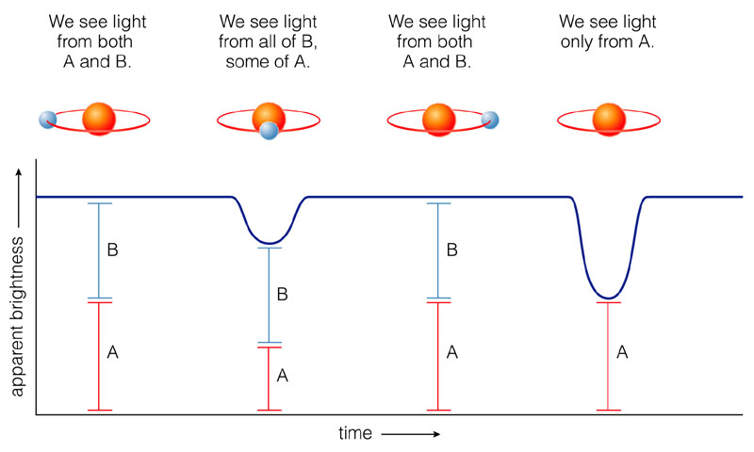

Example #1
Spectral Class | Temperature (K) | Radius (R☉)
04 | 48000 | 14.4
05 | 44500 | 15.0
06 | 41000 | 12.9
07 | 38000 | 11.8
08 | 35800 | 10.8
09 | 33000 | 9.56
B0 | 30000 | 8.47
B1 | 25400 | 6.56
B2 | 22000 | 5.22
B3 | 18700 | 4.17
B5 | 15400 | 4.06
B6 | 14000 | 3.81
B7 | 13000 | 3.54
B8 | 11900 | 3.17
B9 | 10500 | 2.96
A0 | 9520 | 2.71
A1 | 9230 | 2.32
A2 | 8970 | 2.12
A3 | 8720 | 2.01
A5 | 8200 | 1.86
A7 | 7850 | 1.76
A8 | 7580 | 1.71
F0 | 7200 | 1.64
F2 | 6890 | 1.46
F5 | 6440 | 1.44
F8 | 6200 | 1.26
G0 | 6030 | 1.13
G2 | 5860 | 1.02
G5 | 5770 | 0.89
G8 | 5570 | 0.88
K0 | 5250 | 0.79
K1 | 5080 | 0.79
K2 | 4900 | 0.75
K3 | 4730 | 0.76
K4 | 4590 | 0.69
K5 | 4350 | 0.68
K7 | 4060 | 0.64
M0 | 3850 | 0.63
M1 | 3720 | 0.60
M2 | 3580 | 0.55
M3 | 3470 | 0.53
M4 | 3370 | 0.41
M5 | 3240 | 0.33
M6 | 3050 | 0.26
M7 | 2940 | 0.23
M8 | 2640 | 0.17
M9 | 2510 | 0.09

Suppose that you had a F5 and a G5 star orbiting each other at separation distance of 4 solar radii (R☉). If these are main sequence stars then we can estimate the properties of these stars to be as follows:

Star | Class | T (K) | R (R☉) | R (pole)
1 | F5 | 6440 | 1.44 | 0.36
2 | G5 | 5770 | 0.89 | 0.22

Note that the “pole radius” is defined to be the ratio of the star radius to the binary star separation distance. This means that Star 1 is about 36% of the star separation distance
(e.g. 1.44/4 = 0.36 = 36%).


1.44 R☉
4 R☉
Using a program call StarLight Pro we can model the light curve for the eclipsing binary star contain the F5 and G5 stars separated by 4 solar radii. The light curve below assumes that the inclination of the orbit is 80 degree.

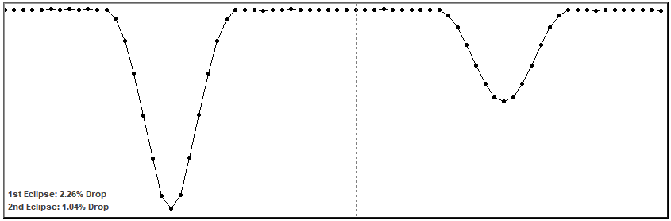

Note that for the first eclipse the star system bright drops by 2.26% and for the second eclipse the system brightness drops by only 1.04%.

1. What is the inclination of the orbit of this same star system for the light curve shown below?

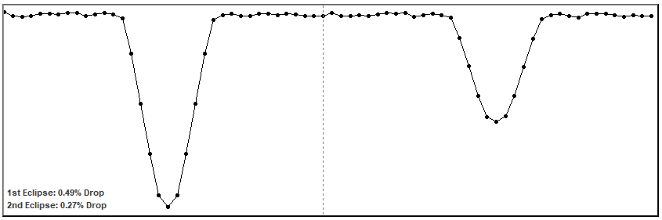

Inclination of the Orbit: ___________

Example #2

Two stars are orbiting one another with an inclination angle of about 89 degrees as seen from Earth. They are orbiting one another with a separation of 2 solar radii. Assume that the two stars are main sequence stars and have the following light curve.

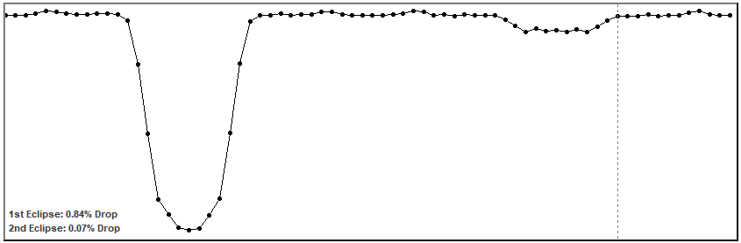

Complete the table below by modeling the light curve above. It is important that both the temperature and radius correspond to a main sequence star.

Star | Class | T (K) | R (R☉) | R (pole)
1 | K1 | 5080 | 0.79
2 |  |  | 0.26

Example #3

Two stars are orbiting one another with an inclination angle of about 80 degree as seen from Earth. They are orbiting one another with a separation of 10 solar radii. Assume that the two stars are main sequence stars.

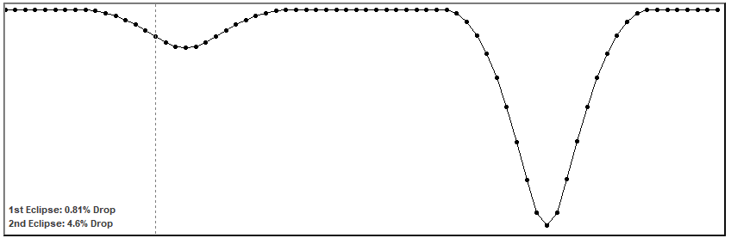

Complete the table below by modeling the light curve above. It is important that both the temperature and radius correspond to a main sequence star.

Star | Class | T (K) | R (R☉) | R (pole)
1 |  | 13000
2 |  | 18700

Types of Eclipsing Binary Stars

Note that eclipsing binary stars can be so close to one another that they exchange matter. Eclipsing binary stars are classified based on how distorted the stars are as a result of gravity.
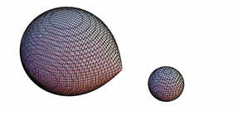
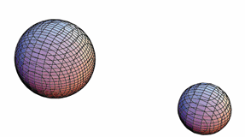

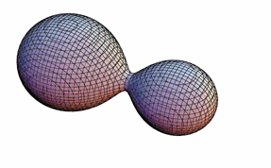
Detached
Semi-Detached

Contact

Turn on “Tidal Effect” and check “Auto” in the StarLight Pro modeling software. Classify the eclipsing binary stars in the table below as detached, semi-detached, or contact.

Eclipsing Binary Star | Type
AD Cnr (4)
WX Eri (88)
SS Ari (23)
HP Aur (72)
RV Crv (82)
V463 Cyg (159)
KX Pup (179)
IT Cas (201)
VW Cyg (313)
FZ Ori (Dan)
V884 Sco (344)
GW Cep (8)

Beta Lyra

Download the photometry data of Beta Lyrae from the homework link on the course home page. Use scatter plots rather than line plots for the graphs below.

Plot #1: Make a plot of apparent magnitude versus Julian Day and staple it to your homework.
i) Label your axes ‘Apparent Magnitude’ and ‘Julian Day’ on your X-Y scatter plot.
ii) Remember to plot the apparent magnitude in reverse order.
This will make ensure that brightness is increasing vertically on your graph.
iii) Use 2449100 to 2449700 in increments of 100 for your Julian Day axis.
iv) Use 3 to 4.5 in increments of 0.5 for your apparent magnitude axis.

Plot #2: Now make plot of apparent magnitude versus orbital phase and staple it to your homework. Orbital phase is the fractional part of (Julian Day - 2448987.54) / 12.93784 in the case of Beta Lyrae. You can enter the following in cell C1 for example: =(A1-2448987.54)/12.93784. To find the factional part of a number in cell C1 in Excel you would enter the following: =C1-INT(C1)
i) Label your axes ‘Apparent Magnitude’ and ‘Orbital Phase’ on your X-Y scatter plot.
ii) Remember to plot the apparent magnitude in reverse order.
iii) Use 0 to 1 in increments of 0.2 for your Orbital Phase axis.
iv) Use 3 to 4.5 in increments of 0.5 for your apparent magnitude axis.

(a) Create a new tab for your web page labeled “Beta Lyra”. Add your Plot #2 to this web page.

(b) What is the orbital period of Beta Lyrae? ________________ (include units)

(c) What is the magnitude of Beta Lyrae at the time of primary minimum? _____________

(d) What is the magnitude of Beta Lyrae at the time of secondary minimum? ______________

(e) What is the magnitude of Beta Lyrae at maximum brightness? _______________

(b) Why is Plot #2 more useful than Plot #1. Clearly explain below.

