Name: ______________________________________

Astronomical Data Analysis

Plot 1: The Shape of the Horizon (Use a Spreadsheet)
On the equatorial star charts we approximated the east and west horizons as straight vertical lines. We will now compute and plot the true shape of the horizon. From this plot we will be able to see why Canopus, for example, is above the horizon for only a few hours each day, while Capella is above the horizon for more than 12 hours each day.

- Create a new Google Sheet at sheets.google.com and add a link to your sheet on the Google Sheet for the class located on the course News section in D2L.
- To create your plot showing the shape of your horizon on a star chart, first create a column of azimuth values from 0 to 360 degrees in increments of 5 degrees. Then add columns for hour angle, right ascension and declination.
- Use equations from section 26 of your text book to find α and δ. Assume that LST=12^{h} and that you are in Nacogdoches. Note that for points along your horizon the altitude is zero (a=0).
- Create a plot of declination versus right ascension.
- Use a declination range of -60° to 60° and a right ascension range of 0^{h} to 24^{h}.
- 24^{h} should be on the left side of your graph and 0^{h} should be on the right.
- Use data point symbols (○) with a smooth curve drawn through these data points.
- Hint: You will need worksheet columns for A, H, δ, and α. Use decimal degrees for all of these except α. Note that Excel trig functions use radians. For example, type “=COS(45*Pi()/180)” in a cell and hit return. Also try “ = ACOS(1) * Pi() / 180”.
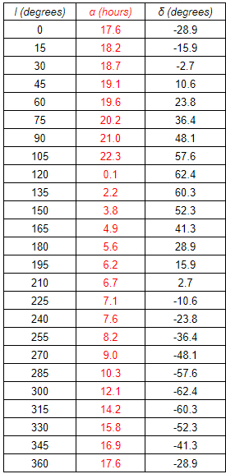
Plot 2: The Messier Catalog (Plot by Hand)
During the years from 1758 to 1782 Charles Messier, a French astronomer (1730 - 1817), compiled a list of over 100 diffuse objects that were difficult to distinguish from comets through the telescopes of the day. Discovering comets was the way to make a name for yourself in astronomy in the 18th century -- Messier's aim was to catalog the objects that were often mistaken for comets.

- Locate Table 12 from the Stars and Planets text.
- Plot all 110 Messier Objects on the star charts provided.
- Use a different plot symbol for each type of object:
  - Nebulae (◊)
  - Globular clusters (*)
  - Open clusters (□)
  - Galaxies (○)
- The table shown contains the coordinates of the plane of the galaxy and was generated in Excel using equations from section 30 of your text book. Plot these points on Start Chart 1, 2, 3, and 4 and draw the galactic plane as a curve among your Messier objects. Note that for points along the plane of the galaxy the galactic latitude is zero (b=0). Note that l is the galactic longitude in the table.
- Label the center of the galaxy on two of your star charts.

Be sure to answer the questions on the back of this page.
Questions

1. According to Plot 1, how long is Canopus above the horizon in Nacogdoches? How long is Capella above the horizon? Use the declination of these stars for your estimates. Express your answer in decimal hours.

________________ _______________

2. Why are no Messier objects found below a declination of -40 degrees on Plot 2? Use complete sentences for your answer.

3. Match the objects below with the descriptions below. The selections may be used more than once.

Nebula ____________ Open Clusters _____________

Globular Clusters _____________ Galaxies _____________

(a) These objects cannot be found near the plane of our galaxy. The material within the Milky Way has created a “zone of avoidance” by blocking our view of these objects.
(b) These objects can be found mostly near the plane of our galaxy.
(c) These objects appear mostly around the center of our Galaxy. Harlow Shapley used these to measure the distance to the center of our galaxy.
(d) These objects are scattered uniformly across the sky.
(e) These objects can be classified as “reflection”, “emission”, or “planetary”.

4. Where do you not find Galaxies on the star charts? Why? Explain. Use complete sentences for your answer.

5. Name two types of clusters found in the Messier Catalog.

_________________________________________________

6. Name three classes of galaxies found in the Messier Catalog.

_________________________________________________

7. Name three types of nebulae found in the Messier Catalog.

_________________________________________________

8. On which two Star Charts does the galactic center appear? (Be sure you labeled the galactic center on both charts.)
_________________________________________________

9. Can you see the galactic center from Nacogdoches?
_________________________________________________

